Websites  What are the types of teeth? - BBC Bitesize  What is the digestive system? - BBC Bitesize  Children's teeth - NHS (www.nhs.uk)  Take care of your teeth and gums - NHS (www.nhs.uk)  Experiments  Fun Science Teeth Experiment - Fun Science UK (fun-science.org.uk)  Digestive System - Experiment at Home - Fun Science UK (fun-science.org.uk)  How to model digestion using tights - BBC Bitesize | Videos  How to care for the teeth children aged 7+ with Dr Ranj and Supertooth! - YouTube  Digestive System | The Dr. Binocs Show | Learn Videos For Kids - YouTube  Places to visit  A fun-packed family day out for children aged 0-11 - Eureka!  Craft Ideas  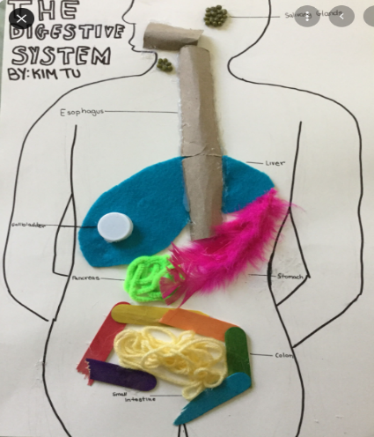
Year 4 Teeth and Digestion

