Websites  https://www.tate.org.uk/art/artists/sonia-boyce-obe-794  https://www.royalacademy.org.uk/art-artists/name/sonia-boyce-ra  https://www.hauserwirth.com/artists/sonia-boyce/  https://www.theguardian.com/artanddesign/2022/apr/17/artist-sonia-boyce-paintings-are-not-born-on-walls  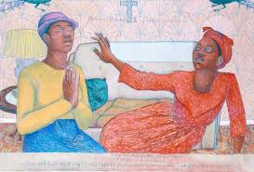 | Videos  https://www.youtube.com/watch?v=fQqH_i50cjg  https://www.youtube.com/watch?v=7IPiutaoT2s  https://www.youtube.com/watch?v=acdHXZGiPyA  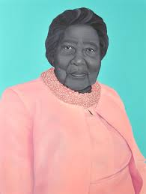
Year 5 Art: Sonia Boyce

