Websites  School Learning Zone - Volcanoes and Earthquakes (school-learningzone.co.uk)  Volcano facts | National Geographic Kids (natgeokids.com)  Physical geography - Volcanoes - Year 5 - P6 - Geography Collection - Home Learning with BBC Bitesize - BBC Bitesize  Earthquake (nationalgeographic.com)  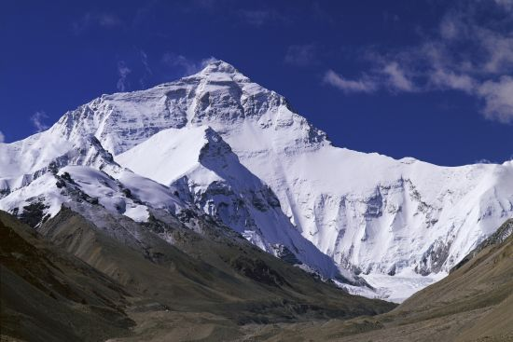 | Videos  Key Stage 2: Mountains, volcanoes and earthquakes - YouTube  Why do volcanoes erupt? - CBBC Newsround  Activity Ideas  - Find the tallest mountains on each continent.  - Explore some mountains and volcanoes using Google Earth.  - Open Google Earth and explore the topographic features on the Earth's surface. Observe where the major mountain ranges are. Can you find: The Rocky Mountains, Alps, Andes, Himalayas, Appalachians? What about mountains closer to home?  - Watch the following videos to gain a basic understanding of earthquakes:  ​Brain Pop - Earthquakes  ​National Geographic - Earthquakes 101A  National Geographic - Earthquakes 101B
Year 3 Mountains, Volcanoes and Earthquakes

