Websites  https://www.bbc.co.uk/bitesize/topics/zshp34j/articles/zpr3bqt  https://www.bbc.co.uk/bitesize/topics/zshp34j/articles/zntxgwx  https://www.bbc.co.uk/bitesize/topics/zshp34j/articles/zqwpsk7  https://www.bbc.co.uk/bitesize/topics/zshp34j/articles/zff4kty  https://www.bbc.co.uk/bitesize/groups/c6z3rpyvkypt  https://www.bbc.co.uk/bitesize/topics/znfng2p/articles/z362nk7 | 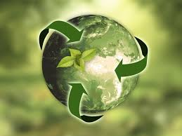
Year 5 Geography: Sustainability

