Websites  Architecture through the ages  Architecture Timeline of Important Historic Periods (thoughtco.com)  Top 10 Ages of Architecture - Listverse  British architecture through the Ages - Hortons – Hortons  Famous Architects  BBC Radio 4 - Woman's Hour, Woman's Hour Power List - Zaha Hadid  Antoni Gaudí - Works, Facts & Death - Biography  Hundertwasser - Architecture  Royal Institute of British Architects  Explore architecture | Videos  The history of architecture | History – Proud To Be - YouTube  Life and works of Antoni Gaudi in Barcelona - 2nd level Art and Design - BBC Bitesize  PSHE KS1 / KS2: Proud to be an architect - BBC Teach  Manchester Arena Glade  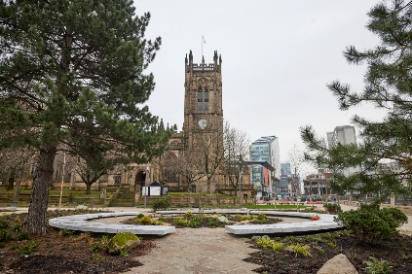  Darwen Tower  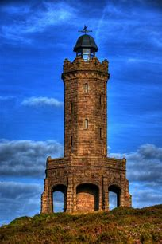
Year 5 Architecture

