Websites  https://teachers.thenational.academy/lessons/what-challenges-do-people-face-living-in-slums-c9j32e  https://kids.kiddle.co/Slum  https://www.habitatforhumanity.org.uk/what-we-do/slum-rehabilitation/what-is-a-slum/  https://www.geographyinthenews.org.uk/issues/issue-20/living-in-rio/ks2/ | Videos  https://www.youtube.com/watch?v=WLX6DVBxUhw  https://www.youtube.com/watch?v=MUsM0h0wSOI  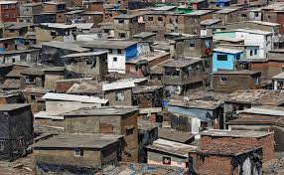
Year 5 Slums: Hinterland

