Websites  History  https://www.jorvikvikingcentre.co.uk/  https://www.bbc.co.uk/bitesize/topics/ztyr9j6  https://www.dkfindout.com/uk/history/vikings/  https://www.natgeokids.com/uk/discover/history/general-history/10-facts-about-the-vikings/  https://historyforkids.org/the-vikings-facts-for-kids/  Norse Myths  https://www.storynory.com/category/myths/norse/  https://www.bbc.co.uk/teach/class-clips-video/english-ks2-viking-sagas/zvrmy9q  https://vikings.mrdonn.org/myths.html | Videos  History  https://www.youtube.com/watch?v=NuL0Q0tsid4  https://www.youtube.com/watch?v=X0QnGvl3rJo  https://www.youtube.com/watch?v=ugE24g1zehg  https://www.youtube.com/watch?v=UpxIGTvKwOE  Norse Myths  https://www.youtube.com/watch?v=ByCTeTI3SDg&t=188s  https://www.youtube.com/watch?v=8Poklx9Ifz4  https://www.youtube.com/watch?v=e6XeP9gQPmg  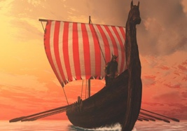
Year 5 The Vikings

