Websites  Greek pottery | Types, Styles, & Facts | Britannica  Ancient Greek Pottery - World History Encyclopedia  Greek Pottery - History of Ceramics in Ancient Greece (artincontext.org)  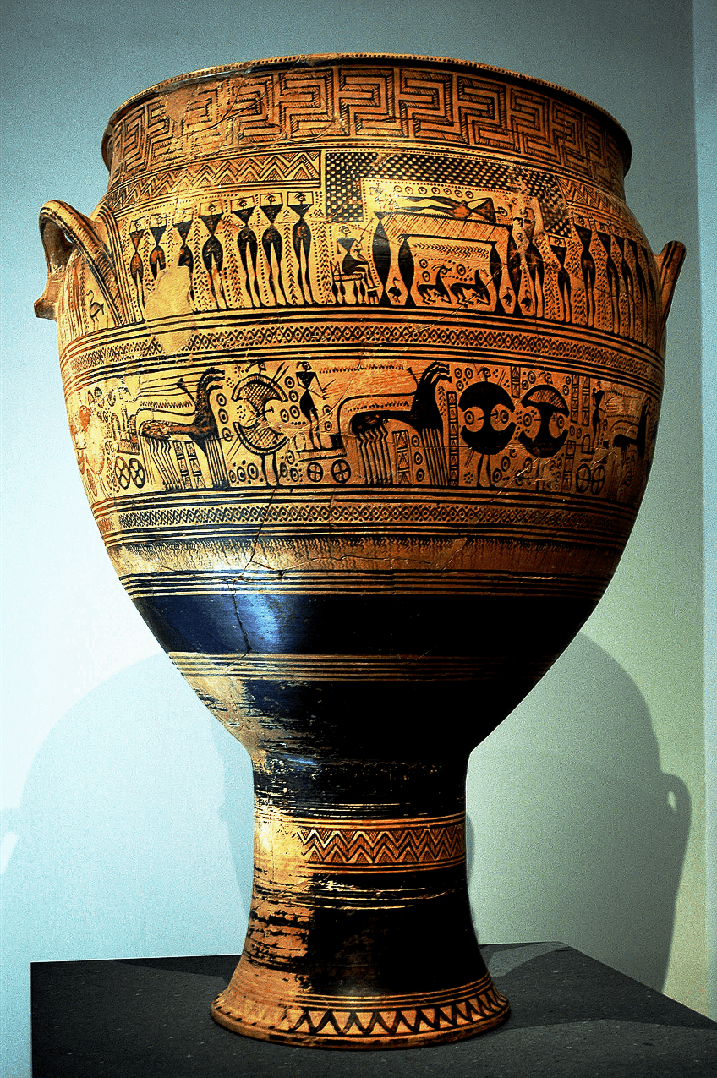  Greek vases | British Museum  Pottery in Antiquity - World History Encyclopedia | Videos  Bing Videos  Bing Videos  Bing Videos  Bing Videos  Bing Videos  Activities  Bing Videos  Bing Videos  Bing Videos
Year 3 Art Hinterland- Ancient Greek Pottery

