Websites  What is coding?  https://www.twinkl.co.uk/teaching-wiki/coding  https://www.bbc.co.uk/bitesize/topics/zs7s4wx/articles/zqrq7ty  https://www.bbc.co.uk/bitesize/topics/zs7s4wx/articles/z8ngr82  https://www.bbc.co.uk/bitesize/topics/zs7s4wx/articles/ztkx6sg  https://www.bbc.co.uk/bitesize/topics/zs7s4wx/articles/zmftn9q | Activities  https://www.codeforlife.education/rapidrouter/  https://www.purplemash.com/app/code/chimp/codefish  Then children can progress from chimp – gibbon - gorilla  https://www.codewizardshq.com/coding-for-kids-free/#codekarts  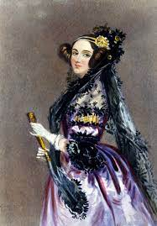Ada Lovelace – known as the first computer programmer
Year 5 Coding

