Greta Thunberg |  | 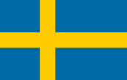
2003  3rd January | 3rd January 2003 Stockholm, Sweden  Mother – Malena Emman (Opera Singer)  Father – Svante Thunberg (Actor) | 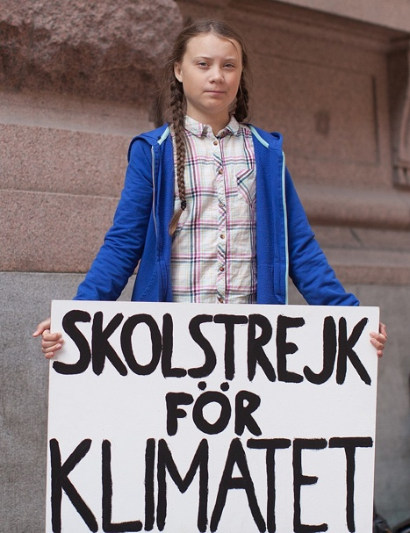
2011 | Greta first heard about climate change at school.
2013 | Greta became a vegan to lower her carbon footprint. This means she does not eat animals or any products from animals.
2014 | Greta was diagnosed with Asperger’s Syndrome, which means she can have difficulty relating to other people and be rigid and repetitive in her routines and beliefs. She calls it her ‘Superpower’.
2015 | Greta convinced her family to give up flying on aeroplanes and began upcycling items to combat climate change.
2018  20th August | Great took part in her first school strike outside the Swedish parliament against climate change.
2019  15th March | Over one million people go on a school strike in 125 countries worldwide. | Useful Videos  Little People, Big Dreams  How Dare You Speech  Greta meets David Attenborough  Greta hosts the Today Programme  The Guardian Short Film
2019  May | A book called No One Is Too Small to Make a Difference was released. A collection of 11 of Greta’s speeches.
2019  September | Greta sailed via a yacht to the UN Climate Action Summit (in New York) to avoid contributing to climate change.
2019  23rd September | Greta gave her speech at the UN Climate Action Summit, remembered as “How Dare You!”, to world leaders challenging their inaction on climate change.
Climate Change | The long-term change in weather patterns across the world caused by humans through burning fossil fuels, chopping down trees and disposing of waste.

